**DevOps eval:**

**Docker version, pull, logs, ps:**

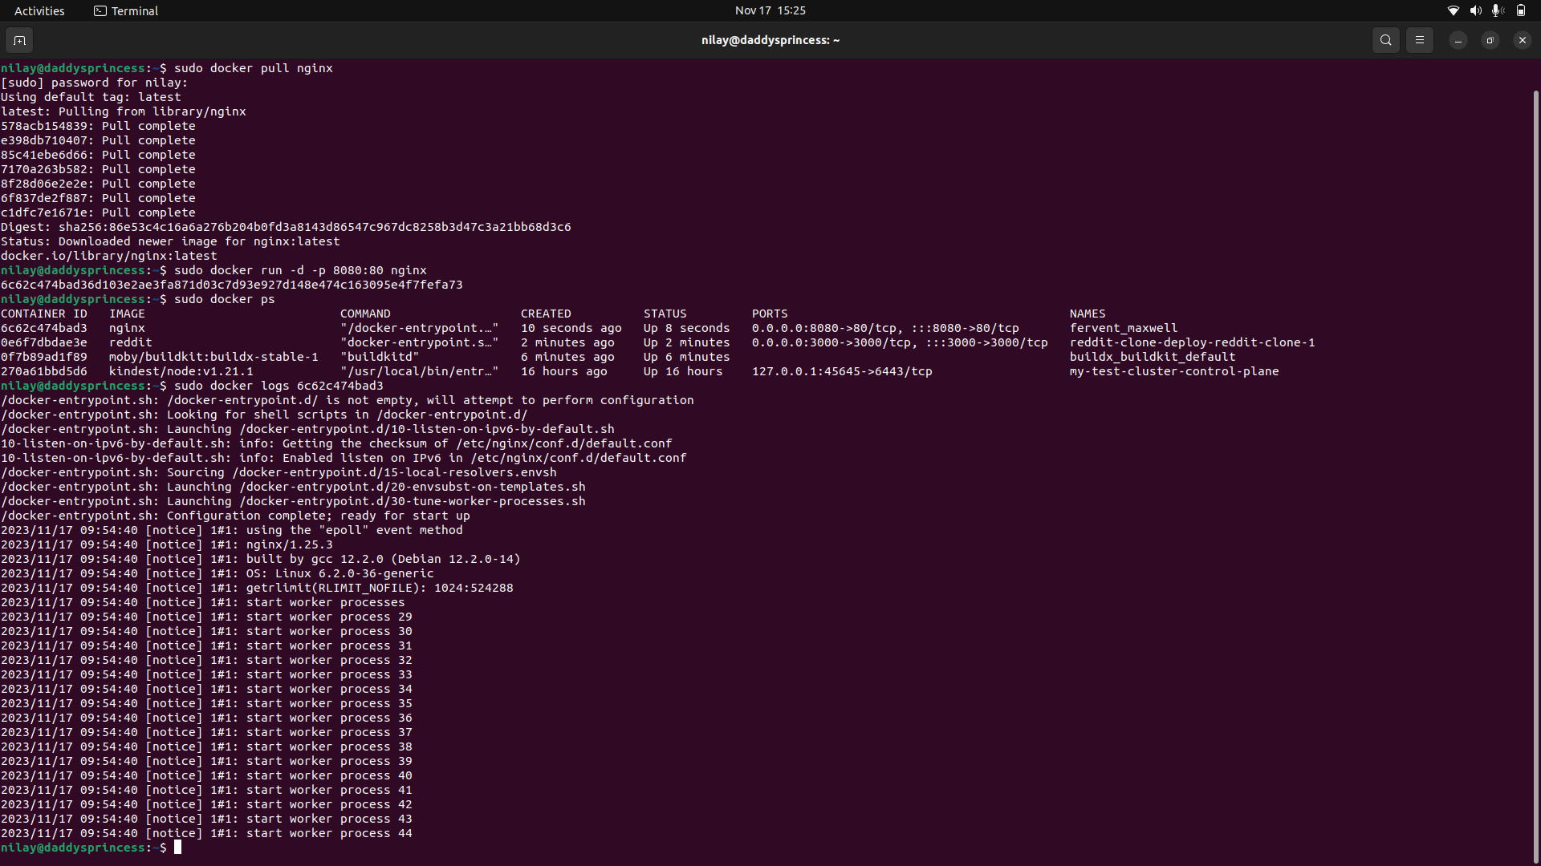

**Docker build, push, compose:**

